Assignment 11.2

1. Find the number of students who scored less than 5(50%).

CODE :

A = LOAD ‘/home/acadgild/studentDS.txt’ USING PigStorage (‘,’) AS (name:chararray, col:chararray, Dob:chararray, Stream:chararray, Grade:float, State:chararray, City:chararray);

B = FILTER A by Grade < 5.0f;

C = GROUP B all;

D = FOREACH C generate COUNT(B.name);

DUMP D:

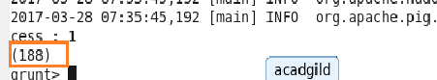

1. List the name of students who are from Alaska.

CODE :

A = LOAD ‘/home/acadgild/studentDS.txt’ USING PigStorage (‘,’) AS (name:chararray, col:chararray, Dob:chararray, Stream:chararray, Grade:float, State:chararray, City:chararray);

B = FILTER A by State == ‘alaska’;

C = FOREACH B GENERATE name;

DUMP C;

Output :

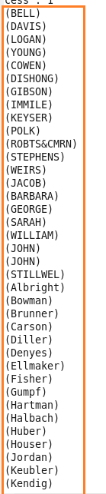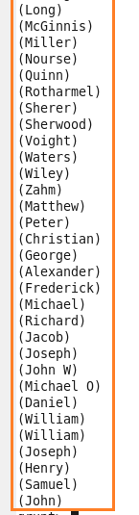

1. How many government colleges are there in Alabama?

CODE :

A = LOAD ‘/home/acadgild/studentDS.txt’ USING PigStorage (‘,’) AS (name:chararray, col:chararray, Dob:chararray, Stream:chararray, Grade:float, State:chararray, City:chararray);

B = FILTER A by col ==’goverenment’ AND State == ‘alabama’;

C = GROUP B all;

D = FOREACH C generate COUNT(B.col);

DUMP D;

Output :

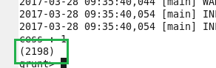

1. List the name of students who are from Oregon and persuing BE.

CODE :

A = LOAD ‘/home/acadgild/studentDS.txt’ USING PigStorage (‘,’) AS (name:chararray, col:chararray, Dob:chararray, Stream:chararray, Grade:float, State:chararray, City:chararray);

B = FILTER A by $5 ==’oregon’ AND $3 ==’BE’;

C = FOREACH B generate name;

DUMP C:

Output :

